**Flask Blog Lite – Project Report – 15th January, 2023**

**Done by**PRANAV R  
[21f2004199@student.onlinedegree.iitm.ac.in](mailto:21f2004199@student.onlinedegree.iitm.ac.in)

**Description:**

This app has the basic functionalities of a blog such as Create, Read, Update and Delete both the Users and Posts and lets users to follow one another.

**Languages/Frameworks Used:**

1. Flask and its related packages (flask_login, flask_wtf, etc.)
2. Flask-SQLAlchemy for SQLite3 database integration
3. SQLiteDB – Database Management
4. Jinja2 – HTML Markup Language
5. Bootstrap – For styling the app (included via CDN)

**Directory Architecture:**

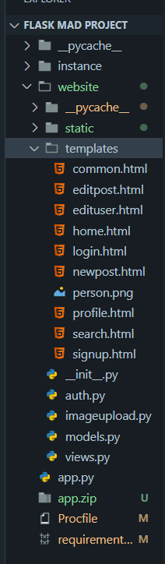 Here you can see the directory structure. The root folder contains the project folder. It also contains the requirements.txt and Procfile.

The Static and Templates folders covert the respective static files and templates according to the regular Flask implementation.

app.py runs the app whereas auth.py and views.py contain the respective blueprints for the Flask App.

models.py holds the database schema designed using SQLAlchemy.

Video Link: <https://drive.google.com/file/d/110lNvLuVW62FRO_yMx0KLNAEhXrVloXu/view?usp=sharing>